HTML Assessment Project
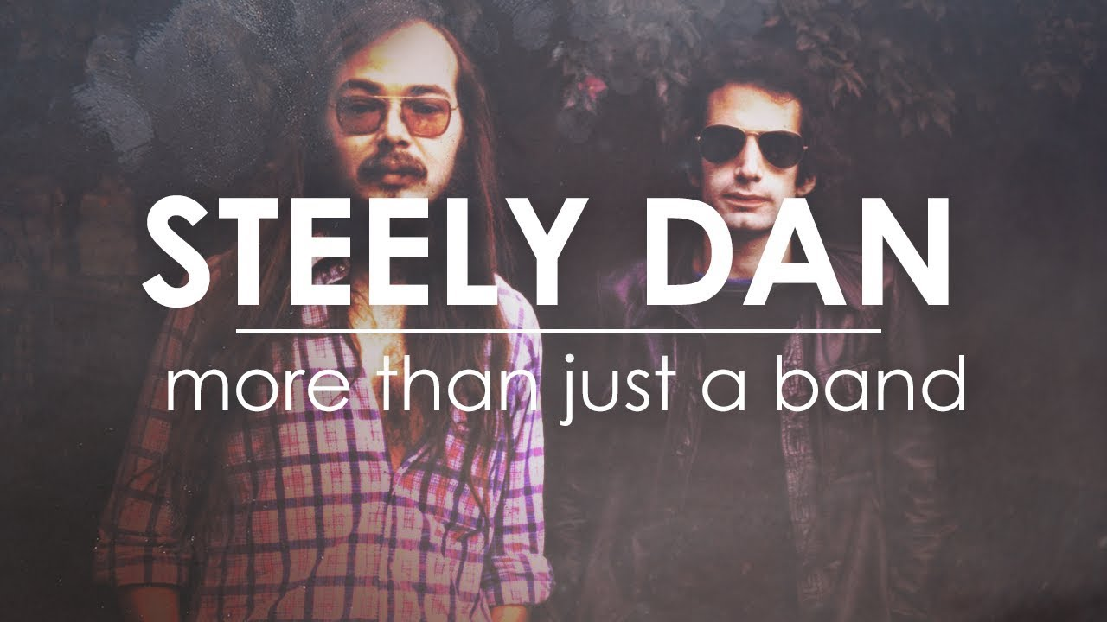

Your task
To create a website using html pages and a cascading style sheet file for either a band or a sports team using the skills you have developed over the course of this.

You can either, use your Common Cents Party project as a basis for your own web pages, or create your own from scratch. If you use existing web pages, you should change the CSS file so colours and fonts change; as well as, of course, the content of each page.

Your site must contain a minimum of three pages linked together through a menu and hyperlinks.
- Each page must have a navigation bar
- Each page must link to and use a common .css file for its styling.
- Each page must have at least one main image.
- One page must contain a video

Marks will be awarded for the creativity you show with your web pages and the quality of the content you select for each page.

You are able to use information, images and video from the internet to help you with your work.

For extra marks use the boundaries and spaces techniques you covered in Code Academy.

Assessment Criteria

Fair
The website contains at least 3 pages
Partly working and is easy for the audience to use
Each page contains at least one main image
Good
Follows the audience and purpose for the chosen theme (band or sports team)
At least 3 pages have been created all linking together
Each page contains the navigation bar
Each page links to and uses a common CSS file for styling
At least one page contains a video
High
A fully functional website that the audience can navigate to and from all pages
correctly using the navigation bar
Included a range of different media on the website (text, images, video) following the target audience (band or sport)
Follows a professional/creative theme and contains good quality content linking to
your audience
Excellent
Created the website using my own code and layout design from scratch
Boundaries and spaces techniques used to improve the look of the website
(ie. The use of padding, margins, boundaries etc. Topic 3 on Code Academy)
Exceptional
Created additional pages that fully work/look professional to suit the audience and purpose
Used additional CSS files to adapt the style of the website throughout
Used the bootstrap CSS framework in order to design a more professional looking website (Topic 4 on Code Academy)

This website must be your own work, using all the resources available to you on Teams and what you have completed already (Common Cents Party and Code Academy). The internet can also be used…you may find some really helpful resources in order to improve your website. However, please don’t just copy and paste…this will not get you higher marks.

